Using LASERS to Examine Color by Reflection and Transmission
(Developed from Light Lessons with a Laser Pen by the University of Virginia Physics Department)
Light emitted from a common incandescent light bulb or the sun is incoherent. That is, the light has many different phases of vibrations and wavelengths. The light is as incoherent as the footsteps on an auditorium floor when a mob of people is chaotically rushing about. Incoherent light is chaotic. Interference within a beam of incoherent light is rampant, and a beam spreads out after a short distance, becoming wider and wider and less intense with increased distance.

Even if a beam is filtered so that it is monochromatic (of a single wavelength), it is still
incoherent, for the waves are out of phase and interfere with one another. The slightest differences in their direction results in a spreading with increased distance.

A beam of light that has the same frequency, phase and direction is said to be coherent. There is
no interference of waves within the beam. The name laser comes from Light Amplification by
Stimulated Emission of Radiation. The laser is not a source of energy. It is simply a converter of
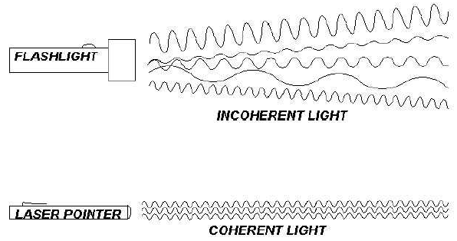
energy and like all devices; a laser can put out no more energy than is put in.

Activity #1: Where, Oh Where has my laser light gone?
Theory: To be able to see something, one of two things must happen: either the light emitted form a luminous source enters your eye, or a fraction of the light emitted from some source is scattered off an object it illuminates and bounces in the direction of your eye. This is how you can see objects that don’t emit light. For example, you can see the moon at night because the light from the sun scatters off the surface of the moon and the moon is illuminated.

Procedure:
- Stand a book up against the wall and shine your laser light on the wall such that your partner cannot see the scattered light (red dot). Alternately turn it on or off and see if your partner can accurately determine whether it is producing light or not.
- Use a spray bottle with water to get little droplets in the air. Then repeat step one and see if their accuracy improves.

How can you tell if the laser is on or off?

Why can we see the spot on the wall of laser light?

If the light were not scattered, what would you see?

What happens when you shine a flashlight up at the sky when it’s pitch black?

Activity #2: Is it Yellow?

Theory:

To the physicist, the colors of things are not in the substances of the things themselves. Color is in the eye of the beholder and is provoked by the wavelengths of light emitted or reflected by things. People diagnosed with colorblindness perceive these wavelengths of light differently.

The color of most objects around you is due to the way the objects reflect light. Electrons are forced into vibration by the vibrations of the absorbed electromagnetic waves (light). Once vibrating, these electrons re-emit energy waves that we perceive as color.

Most materials absorb some wavelengths and reflect or transmit the rest. If a material absorbs all colors except for reflecting red, then the material will appear red. If it reflects all colors it will appear white, if it absorbs all colors it will appear black because there is no light being reflected.
Note: The object only reflects the wavelengths of light that are present in the illuminating light.

Procedure:
- Shine your laser light on various colored papers to check your prediction of what color you will perceive. Record your predictions and observations below:
Paper Color | Color Prediction | Color Observation
Do some colors reflect the laser light better than others do? If so which ones?

What color does a red object appear in red laser light? Why?

What color does a green object appear in red laser light? Why?

What color does a white object appear in red laser light? Why?

What if light from a red and a green laser were mixed on a white screen? Try it!

Activity #3: Rose Colored Glasses!

Theory: A transparent material is one that light is able to pass through. A colored transparent material will absorb incident light but will only transmit light that is of a certain wavelength. The color of a transparent object depends on the color (wavelength) of the light it transmits.

Procedure:
- Predict the color of light that will be transmitted then shine your laser light through a filter. Record your observations and predictions below.

Filter Color | Color Prediction | Color Observation

What color filter was the best absorber (does not let light transmit) of the red laser light?

What color was the best filter for the transmission of red light?

What happens when the red laser light is incident upon a magenta filter?

