Go to http://www.cosi.org/files/Flash/simpMach/sm1.html Name:

What is a simple machine?
- Machines never change the amount of ____________ done, but they change the __________ and ________________ of the force and the distance.
- Two families of simple machines are:
The ___________ Family ( )
The ___________ Family ( )

It’s all about ‘Mechanical Advantage’
- The efficiency of any machine compares the work that comes out of it (___________ work) to the work that goes into it (___________ work).
Efficiency =

The Essence of Simple Machines
 | Name/Type: | Mechanical Advantage = | Draw an Example | Show Calculations for example
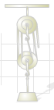
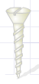
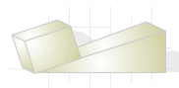
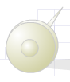
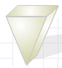

FIND THE SIMPLE MACHINE:
Draw & briefly describe the 3 classes of
levers below:

Class 1:

Class 2:

Class 3:

What is the simple machine in each pic?
- 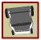 =
- 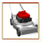 =
- =
- =
- 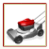 =
- 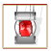 =
- What was your score? _______________
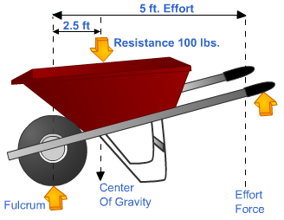
PUTTING SIMPLE MACHINES TO WORK:
(SHOW YOUR WORK FOR EACH PROBLEM!)
Wheelbarrow (Lever)
How much effort in pounds is required to lift the tools?
What is the mechanical advantage of the wheelbarrow?
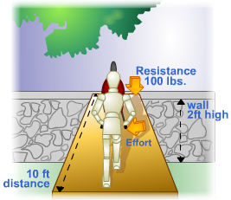
Ramp (Inclined Plane)

If the ramp is 10 feet long and the wall is 2 feet high, what is the mechanical advantage?
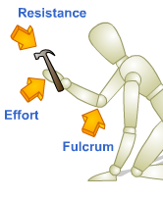
Hammer (Lever) & Nail (Wedge)

Can you tell what class of lever you’ve formed?

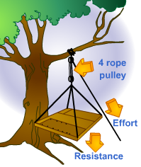
Block & Tackle (Pulley)

If the mechanical advantage of the block-and-tackle is 4, and the floor of the tree house weighs 200 pounds, what force will we need to lift the floor?

Why is it actually slightly more than the correct answer selected?

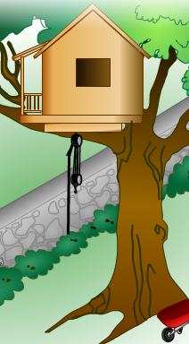
Lag Bolt (Screw)
Which bolt will require the least amount of effort to use?

If each wall weighs 50 pounds and needs to be lifted 20 feet, how much work do we save by using our block-and-tackle? WHY?

GOOD WORK! Literally

There are two ways to think of mechanical advantage:

Ideal MA – based only on the geometry of the system and neglecting friction.
IMA = distance in (effort distance)/distance out (resistance distance) = Δd_{in}/Δd_{out}
Or

Actual MA – where efficiency is always less than 100% due to frictional forces.
AMA = force out (resistance)/force in (effort)

Efficiency = work output/work input = F_{out}Δd_{out}/F_{in}Δd_{in} = AMA/IMA = %
MACHINES AND EFFICIENCY PROBLEMS:

- Two clowns, of mass 50.0 kg and 70.0 kg respectively, are in a circus act performing a stunt with a trampoline and a seesaw. The smaller clown stands on the lower end of the seesaw while the larger clown jumps from the trampoline onto the raised side of the seesaw, propelling his friend into the air. A) What is the ideal mechanical advantage of the seesaw? B) If the larger clown exerts a force of 850.N on the seesaw as he jumps, how much force is exerted on the smaller clown? Draw & label a picture of the scenario before you start solving for the answers. The seesaw is 3.20 m long and the fulcrum is located 0.80m in on one side.

- Jack and Jill went up the hill to fetch a pail of water. At the well, Jill used a force o 20.0 N to turn a crank handle of radius 0.400m that rotated an axle of radius 0.100m, so she could raise a 60.0 N bucket of water. A) What is the ideal mechanical advantage of the wheel? B) What is the actual mechanical advantage of the wheel? C) What is the efficiency of the wheel?

- Clyde, a stubborn 3500 N mule, refuses to walk into the barn, so Farmer MacDonald must drag him up a 5.0m ramp to his stall, which stands 0.50m above ground level.
A) What is the ideal mechanical advantage of the ramp? B) If Farmer MacDonald needs to exert a 450 N force on the mule to drag him up the ramp with a constant speed, what is the actual mechanical advantage of the ramp? C) What is the efficiency of the ramp?

