Red Dot Hits the Spot Challenge!

Introduction:
The Law of Reflection says that the incidence angle will equal the angle of reflection.

Materials:
Laser, 3 mirrors, protractor, graph paper, clay, string

Hint: Try to find 3 of the larger mirrors.

RULE#1 – YOU MAY NOT TURN ON YOUR LASER UNTIL IT IS TIME TO BE GRADED!!
RULE #2 – None of your mirrors can be on the same table.

One suggested Procedure: Try your own if you prefer!

- Tape the graph paper together and place it on your lab table. Put the laser at the end of the table and sketch around the laser so you’ll know where the laser needs to be positioned at all times.
- Draw out the laser beam leaving the laser and hitting the first mirror at whatever angle you decide. Sketch around the mirror in case it gets bumped and moved.
- Using the protractor, find the angle of incidence and then label the angle of reflection and draw the projected reflected beam.
- Continue this process using all 3 mirrors and finally the target.
- Once you are sure of all your measurements and lines, I will turn on the laser and check your progress. If you hit the target, you receive a 100%. If you are off the innermost target either side, you receive a 90%. Each level off deducts 10% from your grade.

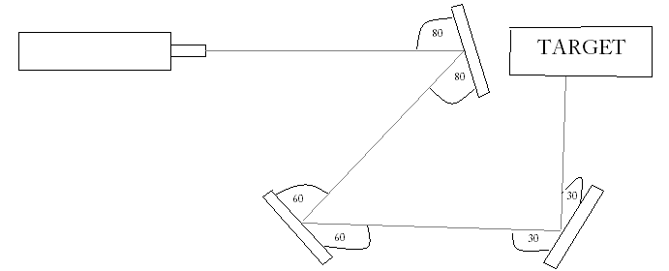
Conclusion:
- State the Law of Reflection in words AND give the mathematical formula.

- Did you hit the target? Why or why not?

- How is this law used in daily life? Give at least 3 examples

