Playground Physics
Playground equipment operates according to the laws of physics. We will use the equipment to better understand Work, Power and Energy.
Your mass: _______ kg Your weight ( F_{grav}): ___________N
The Swing
Law of Conservation of Energy states that energy cannot be created nor destroyed. It can be transformed from one form into another, but the total amount of energy never changes.
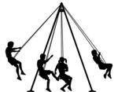
On the drawing, label which locations match the following descriptions:
- Max PE/0KE
- Max KE/0PE
- ½ PE/ ½ KE

PE = mgh KE = ½ mv² Work = ΔKE Power = work/time
Using the equations above, determine the following: (Show your work)

Maximum PE =

Maximum KE =

How fast is the swing moving at position #2?

What is the swings speed at position #1?

To keep returning to the same height at position #1, why does the person have to apply a force periodically?

What other type of energy is being produced besides potential and kinetic based on your previous answer?
The Slide
Find the following pieces of information:
Height (m) of the slide vertically (to the bottom of the slide where it levels off not the ground) =
Length along the actual slide (stop where it levels off – this is the hypotenuse of the triangle – so use Pythagorean Theorem to calculate the length from Δy & Δx) =
Measured slide angle (from where it levels off) =
Calculated slide angle ( θ = inv sin opp/hyp) =
Average angle =
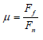
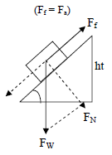
The tangent of the slide angle represents the lowest coefficient of friction (µ) that should allow an object to slide down without any force other than gravity. Calculate it. __________________
Calculate the coefficient of sliding friction using your weight (N) and the average angle you found. (do not use tan θ – use SOH CAH TOA to calculate F_{f} and F_{N} from Fw=hyp. & θ)

Should you be able to slide without pushing? Does gravity alone provide sufficient force?
How much work is done by the person to get to the top of the slide? Power?

What is the person’s potential energy when they are at the top of the slide? What do you notice about the relationship between Potential Energy and Work?
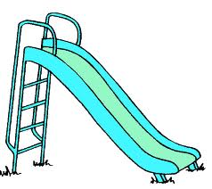
On the drawing, label which locations match the following descriptions:
- Max PE/0KE
- Max KE/0PE
- ½ PE/ ½ KE
Assuming the person went down the slide without producing any heat (thermal energy), what is the person’s velocity at the bottom of the slide?

What is true if a person starts going down a slide but “gets stuck” or stops – is the law of conservation of energy invalid? Explain.

