**Name________________Box #____**

**Date_________________per_____**

**Honors Physics - Investigating Lenses**

**Materials: Converging lens, light source, object, lens holder, screen**

**Part I: Determining the focal length of the lens**

1. Spot a bright object that is a considerable distance away. Project an image of this object on a 3x5 card and measure the distance between the image and the lens.

**This is your focal length______________**

**Situation 1**

1. Set up the optical bench as shown in the figure below.

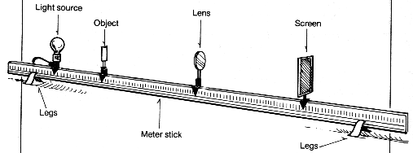

2. For this case, let the lens be **THREE times the focal length** from the object (the object will sit right in front of your light source all the time.

3. Turn on your light and position the screen so you get a sharp image.

4. Measure precisely the distance the object is from the lens as well as the distance the image is from the lens.

**Situation 2**

Repeat the above procedure(s) for the following situations

1. Object is **2 focal lengths** from lens

2. Object is **1.5 focal lengths** from lens

3. Object is **1 focal length** from lens

# Data Table

|  |  |  |  |  |  |
| --- | --- | --- | --- | --- | --- |
| Situation | Do | Di | Real?/Virtual? | Enlarged?/Reduced?/  Same Size? | Upright?/Inverted? |
| 3f |  |  |  |  |  |
| 2f |  |  |  |  |  |
| 1.5 f |  |  |  |  |  |
| At f |  |  |  |  |  |

**Calculations:**

**1.Using the Lens equation  , calculate the focal point for the lens for each situation and show your work below.**

**3f:**

**2f:**

**1.5 f :**

**At f:**

**2. Using the Magnification formula  , calculate the magnification for each situation and show your work below.**

**3f: Did this value fit your observation?**

**2f: Did this value fit your observation?**

**1.5 f : Did this value fit your observation?**

**At f: Did this value fit your observation?**

**3. Using your measured focal length found earlier, determine a % difference for the 2f and 3f situation.**

**4. ON A SEPARATE SHEET OF PAPER, DRAW A RAY DIAGRAM THAT REPRESENTS EACH SITUATION IN THE LAB. USE A SCALE LIKE FOR EVERY 10 CM IN THE LAB WILL EQUAL 1 CM ON MY PAPER.**