Projectile Motion
PhET Simulation

- Log onto your computer. Open the folder titled, Physics 101. Double-click on the PhET Simulations icon.
- When the new window opens, click the “Go to the Simulations” button. In the new window you may get a security message. Click on the message and select “Allow Blocked Content”. After the window opens, scroll down until you find the projectile motion simulation. Click on it.
- You should now be viewing the program as it appears below.

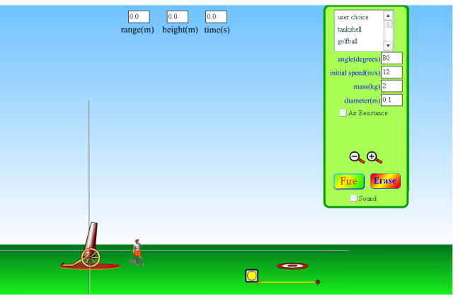

Part A - The Effect of Angle
- From the object’s list, select tankshell. Set the angle to 20 degrees and the initial velocity to 12 m/s. Make sure the Air Resistance box is unchecked.
- Press the Fire button. The tankshell will be fired from the cannon. We now want to measure how high the tankshell traveled and how far it traveled (range).
- Use the measuring tape to determine the maximum range (horizontal distance). NOTE: For ALL of the measurements taken during this lab, we will measure the range from the plus symbol on the cannon along the x-axis to where the object crosses the x-axis as shown below. You cannot use the range value shown at the top of the screen because this includes the projectile’s motion below the x-axis.

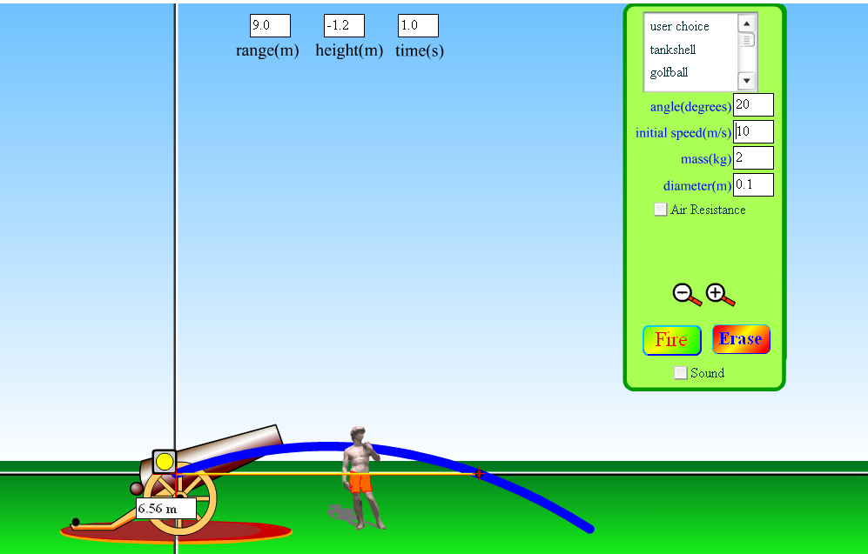
Note the position of the measuring tape
- Move the measuring tape to the midpoint of the projectile path and rotate the tape vertically by clicking and holding the farthest end of the tape. Measure the maximum height of the projectile as shown in the image below.

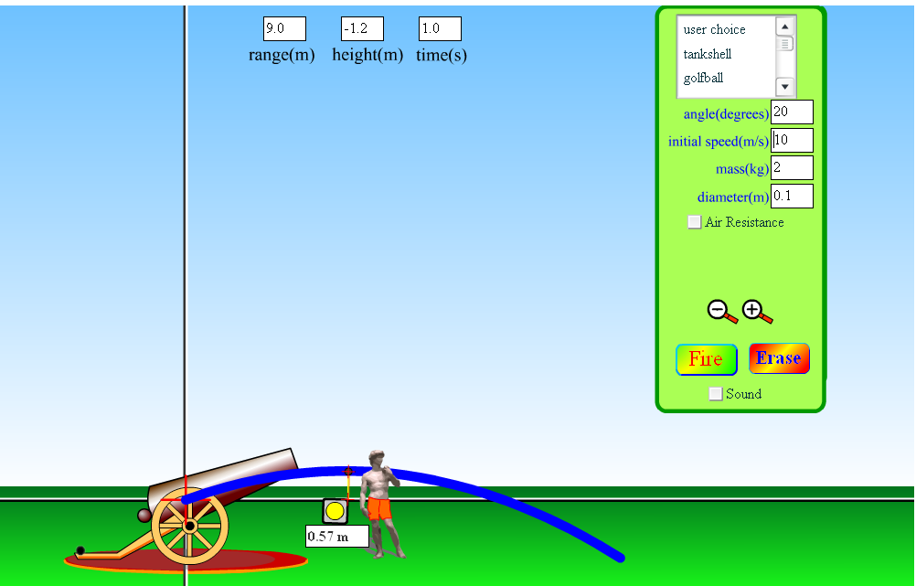
Note the position of the measuring tape

- Record your values in the table below. Repeat your measurements for the other angles provided in your table. Keep all other physical quantities the same.

Angle | Maximum Height (m) | Range (m)
20
30
45
60
70

- Once you have completed all data collection, click the Erase button.

Questions
- How is the range affected by the angle of launch?
- How is the maximum height affected by the angle of launch?
- What relationship exists between angles to produce the same range?
- Assume the tankshell had been fired at an angle of 25 degrees. What other angle would have produced the same range?

Part B – The Effect of Mass
- Select the “Adult Human” as your projectile. Enter an angle of 45 degrees and an initial velocity of 10 m/s. Make sure the Air Resistance box is unchecked. The mass of the human is given as 70 kg.
- Press the fire button. Measure the maximum height and range of the human and record your results in the table below.
- Repeat steps 1-2 twice more; each time making the human 30 kg heavier.

Mass (kg) | Maximum Height (m) | Range (m)
70
100
130

- Once you have completed all data collection, click the Erase button.

Questions
- What effect does mass have on the height and range of a projectile?
- Why does the above effect occur?

Part C – The Effect of Velocity
- You may choose any object for this part. Set the angle to 80 degrees and the velocity to 8 m/s. Make sure the Air Resistance box is unchecked.
- Click the Fire button. Measure the maximum height and range of your projectile and record your results in the table below.
- Repeat the experiment with the same angle and object but increase the speed by 2 m/s with each new trial. Record your answers below.

Initial Velocity (m/s) | Maximum Height (m) | Range (m)
8
10
12
14
16

- Once you have completed all data collection, click the Erase button.

Questions
- What impact does initial velocity have on the maximum height of a projectile?
- What impact does initial velocity have on the range of a projectile?
- Explain why the two relationships you described above make sense in terms of your understanding of gravity and projectile motion.

Part D – The Effect of Air Resistance
- Select the football as your object. Set the angle to 60 degrees and the initial velocity to 12 m/s. Make sure the Air Resistance box is unchecked
- Click the Fire button. Measure the maximum height and range of your projectile. This represents data for the football when there is no air resistance. Record your measurements in the table below.
- Click on the Air Resistance box so a check mark appears.
- Click the Fire button. This is now the path of the football with the same angle and initial velocity but with air resistance (the path is now shown in red). Record your measurements below.
- Repeat the above steps while doubling the drag coefficient in each trial.

Drag Coefficient | Maximum Height (m) | Range (m)
0
0.15
0.30
0.60
1.20

- Once you have completed all data collection, click the Erase button.

Questions
- What impact does air resistance have on the maximum height of a projectile?
- What impact does air resistance have on the range of a projectile?

Part E – Target Practice
You’ll notice the target near the lower right area of the screen. Your goal is to select the golfball and try to hit the target with at least FOUR different combinations of angles and initial speeds. Record your successful results in the table below.

Trial | Angle | Initial Speed
1
2
3
4

