Name:
You will use the L.O.S.T. method to describe the images formed by various mirrors.
Activity 1: Find image distance in a plane mirror using parallax
Parallax – is the phenomenon that the position of an object appears to change when viewed from a different location.
- Two pencils are inserted into rubber stoppers; one stoppered pencil serves as the object and the other serves to assist the student in locating the image.
- The object pencil is placed in front of a plane mirror.
- Then the student sights at the image of the object pencil in the mirror. As a student sights along a line (the line of sight) at the image of the pencil, the second pencil is placed behind the mirror along the same line of sight; this is called the image pencil.
When placed along the line of sight, the portion of the image pencil that extends above the mirror will be aligned with the image that is seen in the mirror.
- The eye location is repositioned to the other side of the object pencil and the process is repeated.
- The precise image location of the object is the location where all lines of sight intersect regardless of where the eye is located.
Will every line of sight allow you to see the image of the pencil?

Measure the distance between the object pencil to the mirror and between the mirror and the image pencil. Record them. Compare the two distances.

Complete the LOST characteristics for this image:
Location: Orientation: Size: Type:

Activity 2: Determine image location using a ray diagram
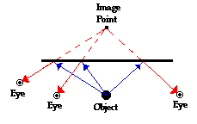
To determine image location you will need to follow the following steps:
- Tape a piece of white paper down on your table top and draw a horizontal line on the paper.
- Place a plane mirror on the line and mount it vertically to the paper with clay.
- Place your pencil between 8-10 cm from the mirror.
- Measure perpendicular to mirror the distance between the object and the mirror. _______
- View the object along different angles (lines of sight) and mark down on the paper an ‘e’ for eye. Draw the angle of incidence from the pencil to the mirror and the angle of reflection from the mirror to your eye. Reminder – using the law of reflection to guide your angle drawing – first put down the normal line (┬) to mirror.
- Do this from 2 locations on each side of the object.
- Remove the mirror.
- Extend the angle of reflection lines in the area that was behind the mirror where you saw the image of the object. If done correctly, all the reflected rays should intersect at the same location; this location corresponds to the image location. Measure from the image location to the mirror line. _________

Were the object distance and image distance measurements the same? Why or why not?

Complete the LOST characteristics for this image:
Location: Orientation: Size: Type:
What can you guess about the characteristics of ALL plane mirror images?

Of the two activities, which one gave you a more accurate image location, Activity #1 or #2? Discuss.

Activity #3: What portion of a mirror do you need to view your whole body?

- Use a tall plane mirror.
- Stand a few meters from a plane mirror and view your image (be sure you can see all of you).
- Stand upright and still and stare at your feet; the lab partner moves a marker up and down the mirror until the sight location on the mirror is identified. The partner then marks this location on the mirror with an erasable marker.
- The process is repeated for the student staring at the tip of her head.
- Measure the distance between the two marks.
Compare the amount of mirror required to the entire height of the person. What approximate ratio do you get between actual height and mirror length needed?

Would the ratio change if you moved farther away? Try it! What happened?

What if you move closer? Try it! What happened?

Activity #4: Draw ray diagrams to show how light will travel so that Suzie will see the image of the arrow.
I will show an example, you do the same with Diagrams A and B.
- Draw an image of the object.
- Pick one extreme on the image of the object and draw the reflected ray that will travel to the eye as it sights at this point.
- Draw the incident ray for light traveling from the corresponding extreme on the object to the mirror.
4. Repeat steps 2 and 3 for all other extremities on the object.
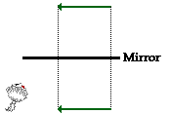
Step 1

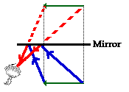
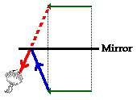
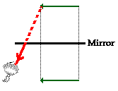
Step 3
Step 4
Step 2

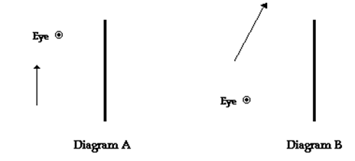
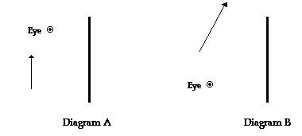

Activity #5: Right Angle Mirrors and Kaleidoscopes

- Set up two mirrors at right angles to each other.
- Place your stoppered pencil between the mirrors.
- How many images do you see? Mark them on the diagram below.
- Mark the location of your eye in the diagram. Draw the paths you think light takes from the object that enables you to see the images.

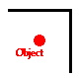

If you observe carefully – what is different about the image that forms where the two mirrors meet compared to the others?

What happens to the number of images if you decrease the angle between the two mirrors?

Decrease the angle even more, now how many images?

One more time…..how many images?

A simple kaleidoscope contains 2 mirrors placed at an angle of 40º for a resulting 8 images. Colored chips in a compartment are placed between the mirrors. The resulting image as the chips move is of 8 identical color patterns.

- Now, put the two mirrors facing each other and parallel in orientation.
- Set your stoppered pencil between the mirrors again.
- How many images do you see?

Why can’t you get an exact number?

