Hit the Line for Your Grade!

In this challenge you will calculate and then predict where a marble will land on the floor after it rolls off the table. Your grade is based on the accuracy of your prediction.

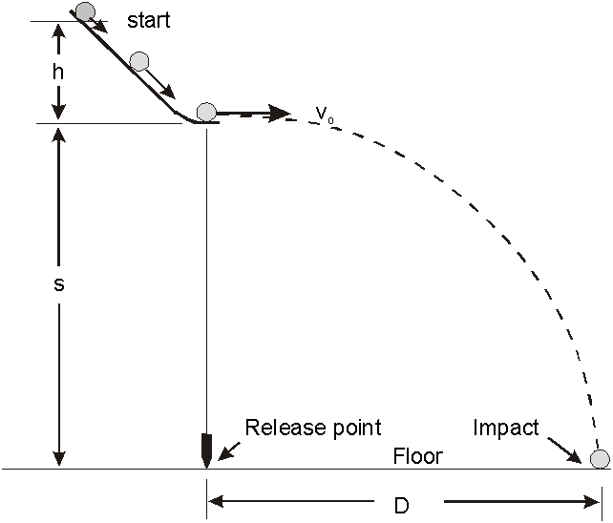
Supplies and Equipment:
v_{x}
- Ramp and marble
- Two photogates with LabQuest
d_{y}
- Plumb bob (to determine the point on the floor directly below the edge of the table)
- Carbon paper with line
- Meter sticks
d_{x}

Rules of play:
- The marble CANNOT roll off the table (even accidently) until you are ready to be graded so have a responsible person in charge of catching it!
- Once you have calculated the landing location, tape down the carbon paper with the drawn line at your calculated distance.
- Get the teacher so you can play the game (get graded)!

Analysis:
- Determine your percent difference. Show your calculations.
- Give at least two reasons why the marble did not exactly hit the line at your calculated distance. Think hard and be specific. With each reason you must explain what effect the error had on your results and how the experiment could be improved to improve or eliminate this error. This is, of course, to be in complete sentences.

