Equipotential Lines and Electric Field
Plotting the Electromagnetic Field

READ THE INFORMATION ON THIS WEBSITE FIRST!
http://www.regentsprep.org/regents/physics/phys03/aequilines/default.htm and look at the “field map” link on that page as well.

PURPOSE
In this experiment, the concept of electric field will be developed by investigating the space
between a pair of electrodes connected to a source of direct current. You will plot equipotential
lines and sketch in lines representing the electric field between the electrodes.

MATERIALS
2 pieces of bare #16–24 gauge copper wire high-resistance voltmeter
2 large binder clips plastic box
2 9-V batteries set of alligator clips (4 per set)

PROCEDURE

1. Tape the grid diagram with the squares and dots onto the outside face of the plastic
container, aligning the edges so that it can be seen through the picture frame.

2. Prepare two pieces of copper wire approximately 50 cm in length (if the wire is insulated, remove about 1 cm of insulation from both ends). Place the wires over the edge of the plastic frame and clip them securely, one to each short side, using a binder clip. Adjust the wires so that the point is down and directly over one of the dots on the paper diagram.

3. Snap the two 9-V batteries together so the positive terminal of one connects to the
negative terminal of the other. This essentially makes a battery with a potential of 18V.

4. Using an alligator clip, connect the negative terminal of the battery to one of the wires
attached to the picture frame with the binder clip. Attach the other wire to the positive
terminal of the battery with another alligator clip. Using a third alligator clip, connect the common or black lead from the voltmeter to the center where the two batteries are
clipped together. To connect to the multimeter, connect the red lead to the port labeled ‘VΏmA’ and the black lead to ‘COM.’ For the complete setup, see Figure 1.

5. Check to make sure the alligator clips that are connected to the positive and negative
terminals and are not also touching the casing of any of the batteries.

6. Add enough tap water to just evenly cover the bottom of the plastic container. Turn the
voltmeter on, making sure it is set for DC volts and set to 200 V. The positive or red lead of the meter is used to measure the potential in the water.
7. Using a second grid, have your lab partner write down the measurements as you move the probe from dot to dot along the rows of dots. Try to keep the probe straight and make sure the water depth is the same all over the plastic container.

Move as quickly as you can—do not be concerned that the readings will not be steady.
These are digital averaging meters. Allow the meter to adjust and record the number that
stays displayed for the longest period of time. Do pay attention to sign (+ or -).

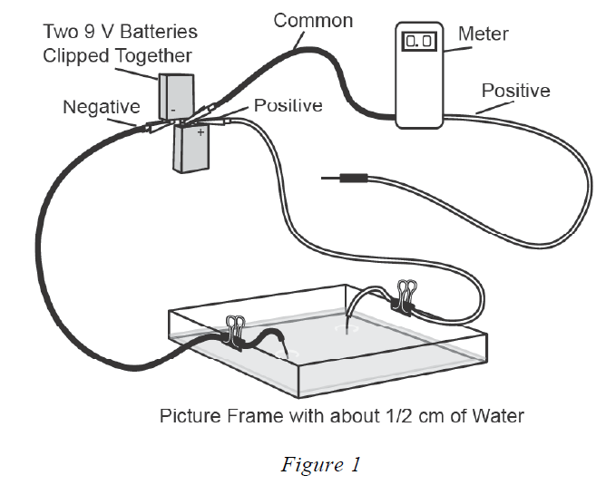

8. With a colored pencil, draw in two sets of equipotential lines by connecting points of equal potential. For each case, draw a smooth curve connecting the points at the given equal potential. The curve is intended to fall along the equipotential between, as well as at, the specific points marked off, so the points should not be connected by straight line segments. This should be done around BOTH electrodes.

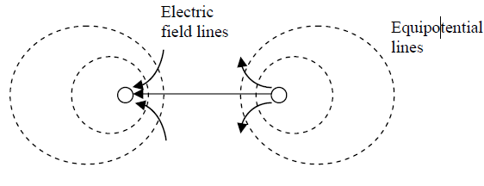
9. After both sets of equipotential lines are drawn, draw a set of electric field lines starting from the positive and going to the negative, crossing each equipotential line perpendicular to the line.

Begin by drawing the first line straight between the two pins. Draw five additional lines above
and five lines below this straight line, keeping the newly drawn lines perpendicular to each
equipotential line. These perpendicular lines that you have drawn on the paper represent the electric field between the two electrodes. The electric field lines are always directed from positive to negative (or from greater positive potential to lower positive potential).

CONCLUSION QUESTIONS:

- Compare and contrast electric field and electric potential.

- In general, how are electric field lines drawn in the vicinity of electric charges?

- Define equipotential line. How are electric field lines and equipotential lines drawn relative to each other?

- Describe the amount of work you would have to do to move a positive charge along:

- An electric field line.

- An equipotential line.

- Describe the strength of an electric field represented by electric field lines that are:

- Closely spaced.

- Equally spaced.

- Use the diagram of showing the equipotential and electric field lines for two small electrodes to calculate the strength of the field between selected points.
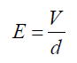
To calculate the strength of the field use the formula at right where V is the difference in electric potential of the points and d is the difference between their distances from the positive terminal.
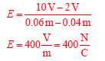

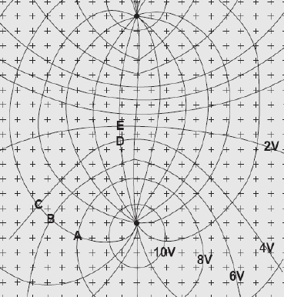

Complete the Chart for the following points:

Points | V | d | E  (V/m)
A to C

B to D

A to E

Mark two points on YOUR grid and calculate the electric field (E) for those points. Show your work.

Adapted from Equipotential Lines and Electric Fields Laying the Foundation®, Inc. Dallas, TX.

