Demon Drop Activity Name:
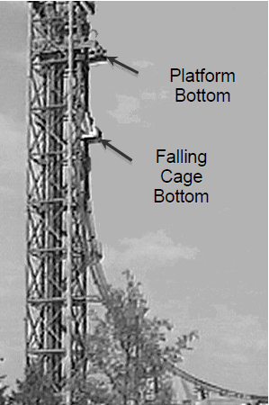
Demon Drop is a popular ride at Cedar Point Park in Ohio. During the ride four people in a cage are in vertical freefall for a short time. Then they ride along a curved track and are
finally brought to a stop while riding along on a straight level segment of track.
Newton’s Law of Gravitation tells us that the Earth exerts a constant force on an object that is close to its surface. If no other forces are present, Newton’s Second Law of Motion
can be used in conjunction with data about the Earth’s mass and radius to predict that an object falling freely near its surface will undergo a constant downward acceleration of
magnitude 9.8 m/s². Is this really the acceleration of the cage full of people? To answer this question you’ll analyze a
video of the of the cage’s fall.

Preliminary Questions:
Open the Logger Pro Experiment file <DemonDrop.cmbl> to obtain a video analysis setup found at t:drive/neugebauert/public/physics/linear motion. This file will open in Vernier Logger Pro with the video embedded in the file. Watch the video a couple of times (you can enlarge it by grabbing the corner and dragging.), then answer the preliminary questions.
As you can see on the first frame of the movie, it has already been scaled based on the Cedar Point Park’s claim that the Demon Drop cage falls 30 m by the time it reaches the level track.

- Watch the DemonDrop.mov frame by frame. How does the cage move? Does it speed up, move at a constant speed, or slow down? What is the evidence for your answer?

- What forces other than the gravitational force might act on the cage as it falls? Do you expect these forces to be measureable? Could they cause the acceleration to be non-constant or deviate from the predicted magnitude of 9.8 m/s²? Explain.

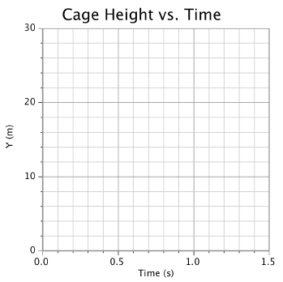
- Note that the cage’s initial position, y1, is almost 30 m above the level track. The cage is already moving downward in the first frame of the movie where t = 0.00 s. By estimating the height of the cage’s bottom in the last frame when t = 1.45 s, sketch a graph that roughly predicts the location of the cage along the vertical y-axis vs. time.

- Describe how you think the slope of the graph will change with time.

Procedure:

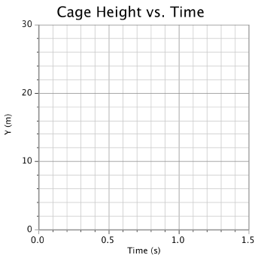
(a) Take y vs. t data by clicking on the Add Point tool ( ) near the top of the movie window. Then click on the same point on the cage in each frame. Logger Pro will then record the vertical position of the cage as a function of time. After doing your video analysis, pull down the Page menu and select Auto Arrange to display the y vs. t graph. Then, sketch your data points on the graph on the right.

Hints: (1) To take data carefully, we suggest that you align the horizontal crosshair of the Add Point tool ( ) with the lower edge of the cage and place the vertical line of the crosshair at the middle of the cage; and (2) If you mess up, start over by using the Clear All Data feature in the Data menu and then returning to the beginning of the movie.

- Based solely on the appearance of your dots, describe the motion of the Demon Drop cage.

- On your position time graph, select the curve fit button in the top menu and select the quadratic equation. Choose ‘try fit’ and ‘OK’. Sketch this graph in the margin. What does the shape of this line tell you about the cage’s motion? Explain.

- Now change the graph to a velocity graph by clicking on the Y (m) on the y-axis and selecting Y – velocity. Then choose the linear regression button and sketch this graph in the margin. What does the shape of this line tell you about the cage’s motion? Explain.

- Look at the slope value. Comment on how well the results of this experiment agree with the prediction of Newton’s theory of Universal Gravitation, ay = –9.8 m/s². Note: Small uncertainties in your measurements can lead to some variation in your results.

- Do you think the Demon Drop is truly a ‘free fall’ ride? Why or why not?

- Let’s assume there were no errors in your measurements. What other forces might be having an effect on the acceleration of the cage?

- How fast is the cage moving at the bottom of the drop? _______________________ List 3 or 4 ideas of how they could make the final y-velocity of the cage faster.

