Wavelength by Diffraction
Adapted from lab by Laying the Foundation
Purpose: In this lab you will measure the wavelengths of six colors of light and light produced by a laser.
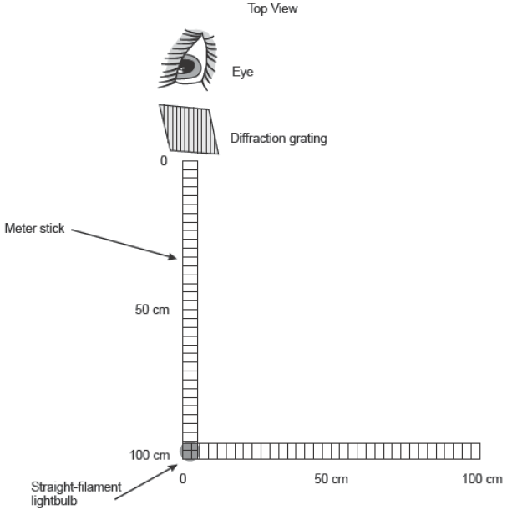
Procedure:
Part I: Measuring the wavelength of colors of light.
- Place a pen light at the end of a meter stick. Place the diffraction grating at the end of the meter stick opposite to the bulb.

- Look at the bulb through the diffraction grating, and note the colored band of light along the perpendicular meter stick.

- Have your lab partner move an index card along the perpendicular stick until the center of the card lines up with the center of one of the colored bands of light.

- Measure the distance x from the bulb to the index card where the colored band was formed. Record this distance in the data table.

- Calculate the wavelength of the color using λ = d sinθ. Use SOH CAH TOA to find the angle θ. First, find the ratio of x/L. (L should be 1.0 meter.) Next, use inverse tangent of the value x/L to get the angle θ and plug it into the equation given.

- Using your calculated value for wavelength and the speed of light (c=300,000,000 m/sec), find the frequency of the color of light.

- Repeat steps 2 – 6 for five other colors of light.

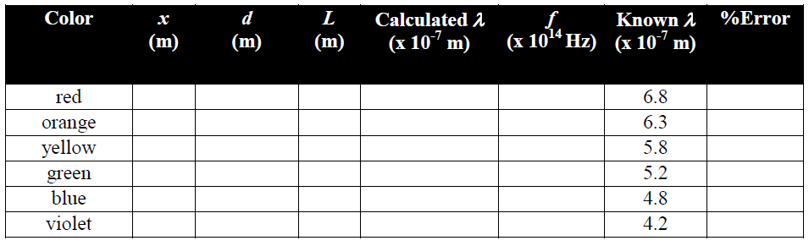
Part II: Measuring the wavelength of Laser Light.
For safety reasons, we will alter the setup a bit.
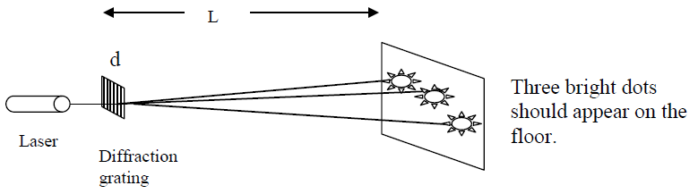
- You will be shining the laser light at the floor. Using a meter stick, put one end of the stick on the floor and hold the diffraction grating on the other end. Place the laser in front of the diffraction grating so that an interference pattern is formed on the floor.

- Using a meter stick, measure the distance from the central maximum (darkest spot in the middle) to the ones on either side. This is distance x as was measured in part I of this lab.

Record your values for Part II:
x=
d=
L=
λ
λ=

Show one example of each type of calculation from Part I below:

Distance (d) in lines/meter between the lines on the diffraction grating (5276 lines/cm):

Wavelength:

Frequency:

Percent Error:

- List your colors from lowest frequency to highest frequency:

- What is the difference between laser light and regular light?

- Compare your calculated wavelength of the laser to the wavelengths of the colors you measured. Does the laser wavelength match the wavelength of the matching color from part I?

- Compare your laser wavelength to the wavelength printed on the laser itself. Calculate percent error.

