Sound Test
Go to: http://www.phys.unsw.edu.au/jw/hearing.html - READ and following the directions on how to correctly use this source to obtain your hearing curve. Mark on this handout your results.
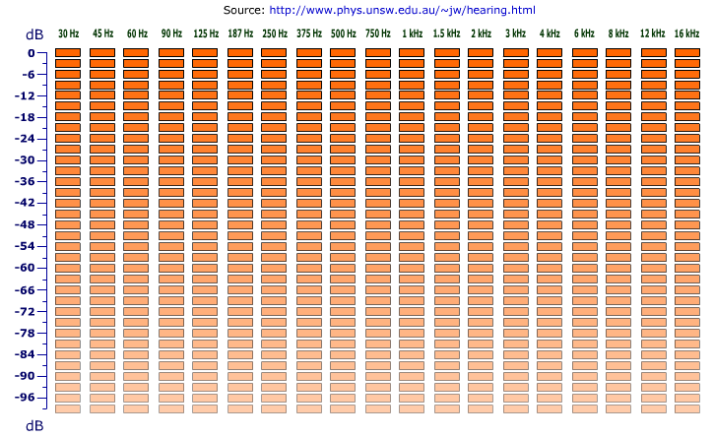

What is a decibel?

How much different is the loudness of 20 dB compared to 30dB? 20 dB compared to 40 dB?

Interpret your hearing curve results. (What does the chart above mean in regards to YOUR hearing?)

Where is your hearing most sensitive? How do you know? Least sensitive? How do you know?

Predict how this curve may change in future years? Why?

