Projectile Motion Vectors
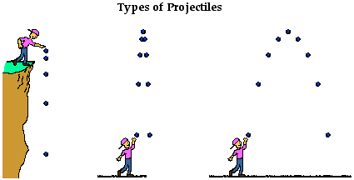
Projectile motion of objects is motion that has both an x-component and a y-component. A cannonball shot from a cannon, a stone thrown into the air, a ball rolling off the edge of a table, a spacecraft circling the Earth- all of these are examples of projectile motion. A projectile is any object that moves through the air or space, acted on only by gravity (and maybe air resistance, if any).

1. Preliminary Questions
(a) Suppose an object is moving in a plane and we choose to describe it using an x-y coordinate system.
If the object is at location x1, y1 at time t1 and at location x2, y2 at time t2, then it has been “displaced.”
The mathematical definition of its displacement vector is
where and are the x and y-components of the object’s displacement in the time period. A
displacement vector is shown in the diagram below. Draw and label the x-component of the
displacement vector (denote it as ) of the vector . Place the tail of the vector at x1, y1. Hint: This vector component points in the x-direction only.
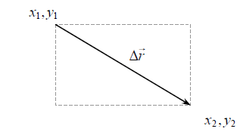

(b) Once again the displacement vector is shown in the diagram below. Draw and label the y-component of the displacement vector (denote it as ) of the vector . Place the tail of the vector at x1, y1. Hints: This component points in the y-direction only and the length of is less than the length of .

Play and watch the video of the ball rolling and falling off the table through to get a general sense of the ball’s motion. Next, starting back at the beginning of the video, select the “add point” tool to mark the location of the ball in each frame of the video. Next, right-click on the graph itself; copy and paste this image into a blank Word document. Paste two more copies on the document and arrange them properly. You will print this document so that you can complete the next portion.

To determine the in each frame, on the first picture use a ruler and draw a vertical line from the top of the picture through the ball’s location to the x-axis at the bottom of the picture. Do this for each frame.

- What happens to the x-component of the ball’s velocity, vx, as the ball moves horizontally? Does it decrease, increase or remain that same? Explain how you know this.

To determine the in each frame, on the second picture use a ruler and draw a horizontal line from the y-axis through the ball’s location to the right side of the picture. Do this for each frame.

- In the first three frames of the movie, what happens to the y-component of velocity of the ball? Does the ball’s vertical velocity component decrease, increase, or remain that same? Explain.

- In the last eight frames of the movie, what happens to the y-component of velocity of the ball? Does the ball’s vertical velocity component decrease, increase, or remain that same? Explain.

On the third picture, draw the x-component and y-component velocity vectors on the ball at each position. Pay close attention to the size of the vectors.

Reflections on your findings:

What do changes in velocity vector components tell us about acceleration? Does the ball accelerate in the X direction? Y direction? Both? Neither? Explain.

What can you conclude about the nature of the horizontal acceleration of this ball based on your
results?

What can you conclude about the nature of vertical acceleration for this ball in frames 4 through 11? Explain your reasoning carefully. Hint: If you take a millimeter ruler and measure the relative length of the vertical velocity vector in frames 4 through 11, approximately how much does the length of the y-component of average velocity between frames change from frame to frame? Is the direction of change positive or negative? Is there a positive or negative acceleration or no acceleration?

