Hit the Target for your GRADE!
Your challenge will be to determine the peak height of the foam bullet shot at a specific angle. Each group will be given a card that contains the angle you must use.
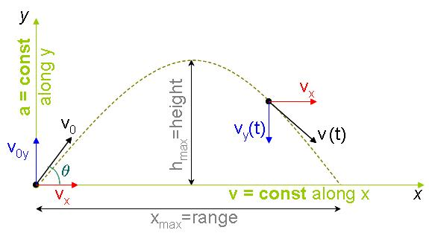
Good Luck!
Equipment:
- Nerf gun
- Ring stand and clamp
- Protractor
- Timer
- Target
- Meter stick

Rules of play:
- You CANNOT shoot your Nerf gun at a wall (even accidentally) until you are ready to be graded.
- Once you have calculated the peak height, tape the target on the wall so that the center of the target is at the calculated peak height distance.
- Get the teacher so you can play the game and get graded!

Analysis:
- Determine your percent difference. Show your calculations.
- Give at least two reasons why the Nerf bullet did not exactly hit the target at your calculated height. Think hard and be specific. With each reason you must explain what effect the error had on your results and how the experiment could be improved to improve or eliminate this error. This is, of course, to be in complete sentences.

