First Semester Review Problems

The hare is sleeping at a location that is 1200 m from the finish line. The tortoise passes him at a steady speed of 5.0 cm/s. If the hare finally wakes up 6.5 hours later, then what minimum acceleration (assumed constant) must he have in order to pass the tortoise before the finish line.

Draw a position-time graph below, sketch a plot representing the motion of an object which is ... . Label each line with the corresponding letter (e.g., "a", "b", "c", etc.)
- at rest.
- moving in the positive direction with constant speed
- moving in the negative direction and speeding up
- moving in the positive direction and slowing down
- moving in the positive direction at a constant speed (slow) and then later fast at constant speed
- moving with a negative velocity and a negative acceleration
- moving with a negative velocity and a positive acceleration

Draw a velocity-time graph below, sketch a plot representing the motion of an object which is ... . Label each line with the corresponding letter (e.g., "a", "b", "c", etc.)
- at rest.
- moving in the positive direction with constant speed
- moving in the negative direction and speeding up
- moving in the positive direction and slowing down
- moving in the positive direction at a constant speed (slow) and then later fast at constant speed
- moving with a negative velocity and a negative acceleration
- moving with a negative velocity and a positive acceleration

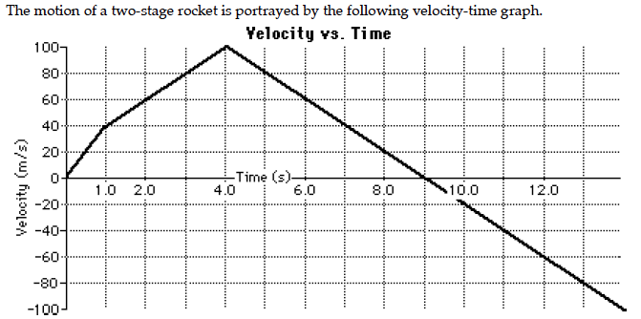

Use the velocity-time graph to answer the following questions:

At what time did the rocket change directions?

During what time interval was the acceleration the greatest? What was the acceleration rate?

From the time interval of 4.0 seconds to 9.0 seconds, what was the rockets displacement?

Construct free-body diagrams for the following objects; label the forces according to type. Use the approximation that g=10 m/s² to determine the magnitude of all forces and the net force and acceleration of the object.

- A 2-kg box is sliding to the right across a table. The force of friction upon the box is 5 N.

- An 8-N force is applied to a 2-kg box to move it to the right across the table at a constant velocity of 1.5 m/s.

A 72-kg skydiver is falling from 10 000 feet. After reaching terminal velocity, the skydiver opens his parachute. Shortly thereafter, there is an instant in time in which the skydiver encounters an air resistance force of 1180 Newtons. Determine the acceleration of the skydiver at this instant.

A 921-kg sports car is moving rightward with a speed of 29.0 m/s. The driver suddenly slams on the brakes and the car skids to a stop over the course of 3.20 seconds with the wheels locked. Determine the average resistive force acting upon the car.

In a grocery store, a shopper walks 36.7 feet down an aisle. She then turns left and walks 17.0 feet straight ahead. Finally, she turns right and walks 8.2 feet to a final destination. (a) Determine the magnitude of the overall displacement. (b) Determine the direction of the displacement vector relative to the original line of motion.

a.  Given:  Launch Vel. = 30.0 m/s  Launch angle = 30.0 degrees | b.  Given:  Launch Vel. = 30.0 m/s  Launch angle = 45.0 degrees | c.  Given:  Launch Vel. = 30.0 m/s  Launch angle = 50.0 degrees
The launch velocity and angle is given for three different projectiles. Use trigonometric functions to resolve the velocity vectors into horizontal and vertical velocity components. Then use kinematic equations to determine the time that the projectile is in the air, the height to which it travels (when it is at its peak), and the horizontal distance that it travels. (To simplify the calculations, use an acceleration of gravity value of -10 m/s/s.)

A projectile is launched horizontally from the top of a 45.2-meter high cliff and lands a distance of 17.6 meters from the base of the cliff. Determine the magnitude of the launch velocity.

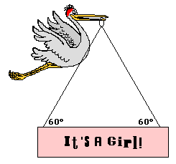
After its most recent delivery, the infamous stork announces the good news. If the sign has a mass of 10.0 kg, then what is the tensional force in each cable?

A 0.530-kg basketball hits a wall head-on with a forward speed of 18.0 m/s. It rebounds with a speed of 13.5 m/s. The contact time is 0.100 seconds. (a) determine the impulse with the wall, (b) determine the force of the wall on the ball.

A 46-gram tennis ball is launched from a 1.35-kg homemade cannon. If the cannon recoils with a speed of 2.1 m/s, determine the muzzle speed of the tennis ball.

In a physics lab, a 0.500-kg cart moving at 36.4 cm/s collides inelastically with a second cart that is initially at rest. The two carts move together with a speed of 21.8 cm/s after the collision. Determine the mass of the second cart.

A student applies a force to a cart to pull it up an inclined plane at constant speed during a physics lab. A force of 20.8 N is applied parallel to the incline to lift a 3.00-kg loaded cart to a height of 0.450 m along an incline that is 0.636-m long. Determine the work done upon the cart and the subsequent potential energy change of the cart.

A 51.7-kg hiker ascends a 43.2-meter high hill at a constant speed of 1.20 m/s. If it takes 384 s to climb the hill, then determine ... . PSYW
- kinetic energy change of the hiker.
- the potential energy change of the hiker.
- the work done upon the hiker.
- the power delivered by the hiker.

An 878-kg car skids to a stop across a horizontal surface over a distance of 45.2 m. The average force acting upon the car is 7160 N. Determine ... . PSYW
- the work done upon the car.
- the initial kinetic energy of the car.
- the acceleration of the car.
- the initial velocity of the car.

