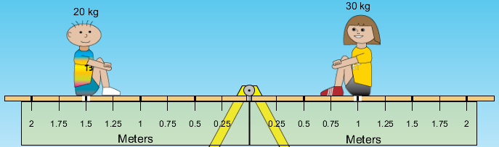Name: _________________________

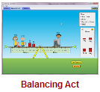

**Balancing Act PhET Lab** (2012)

**Introduction:** Ever had to carry a single heavy sack of books or groceries with one hand? What happens to your body to allow you to do this? How is your body different when you have to carry TWO sacks, one on each side?

How about the classic, teeter totter? Can your successfully totter with someone heavier than you? How? Many people think that weight is all that matters when you balance something but you know that downward force is only a part of the situation.

Some handy vocabulary for you to define:

Force: _______________________________________________________________________________________

Lever Arm: ___________________________________________________________________________________

Torque: ______________________________________________________________________________________

Fulcrum: _____________________________________________________________________________________

Equilibrium: __________________________________________________________________________________

**Procedure:** *Play with the Sims 🡪 Physics 🡪 Motion 🡪 Balancing Act* 

Take some time to play with the simulation. Go ahead. Play. Have fun. Learn. *Are you still reading this?*

Observe the following situations below and draw your prediction of what would be needed to bring all the objects into equilibrium. Test your prediction in the simulation.

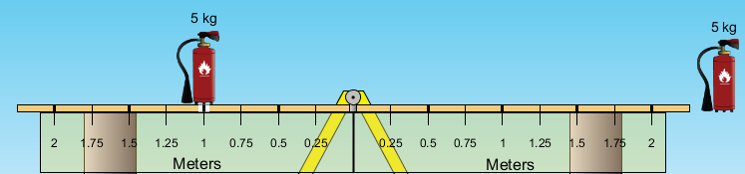

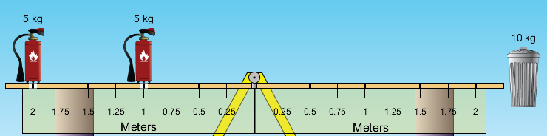

The next few require you to do a little more math…

Calculate exactly where the floating object should be placed to assure all objects are in equilibrium. Show your work below each drawing. *You may check your work in the simulation AFTER calculations.*

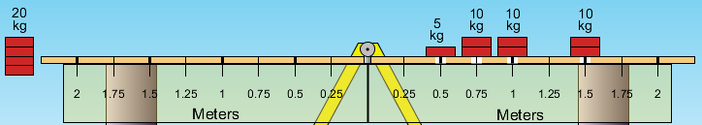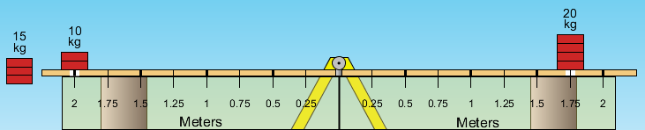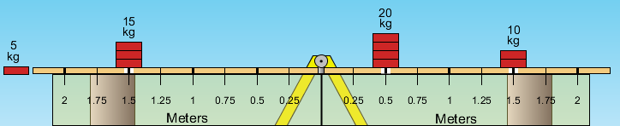

Show your work here. Remember units!

Show your work here. Remember units!

Show your work here. Remember units!

**Finally, go to the Game tab and play all four levels – go for speed and accuracy! Record your stats below:**

|  |  |  |  |  |  |  |  |
| --- | --- | --- | --- | --- | --- | --- | --- |
| **Level 1** | | **Level 2** | | **Level 3** | | **Level 4** | |
| **Score** | **Time** | **Score** | **Time** | **Score** | **Time** | **Score** | **Time** |
|  |  |  |  |  |  |  |  |