Graph Matching Supplementary Document

Preliminary questions

1.
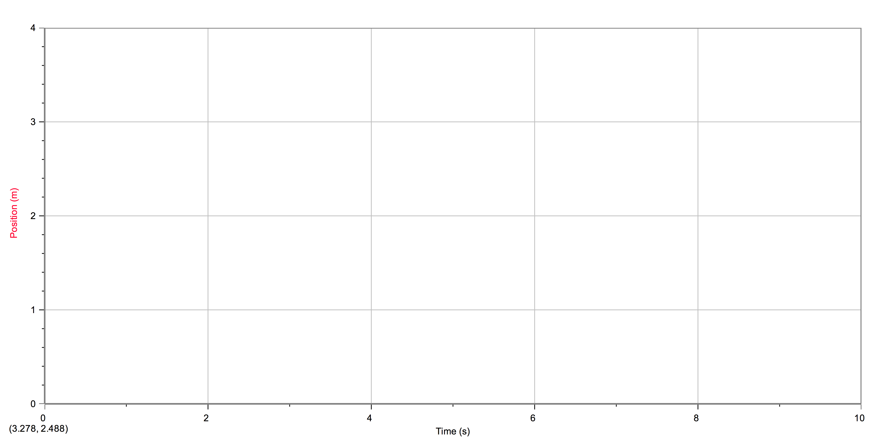

2.
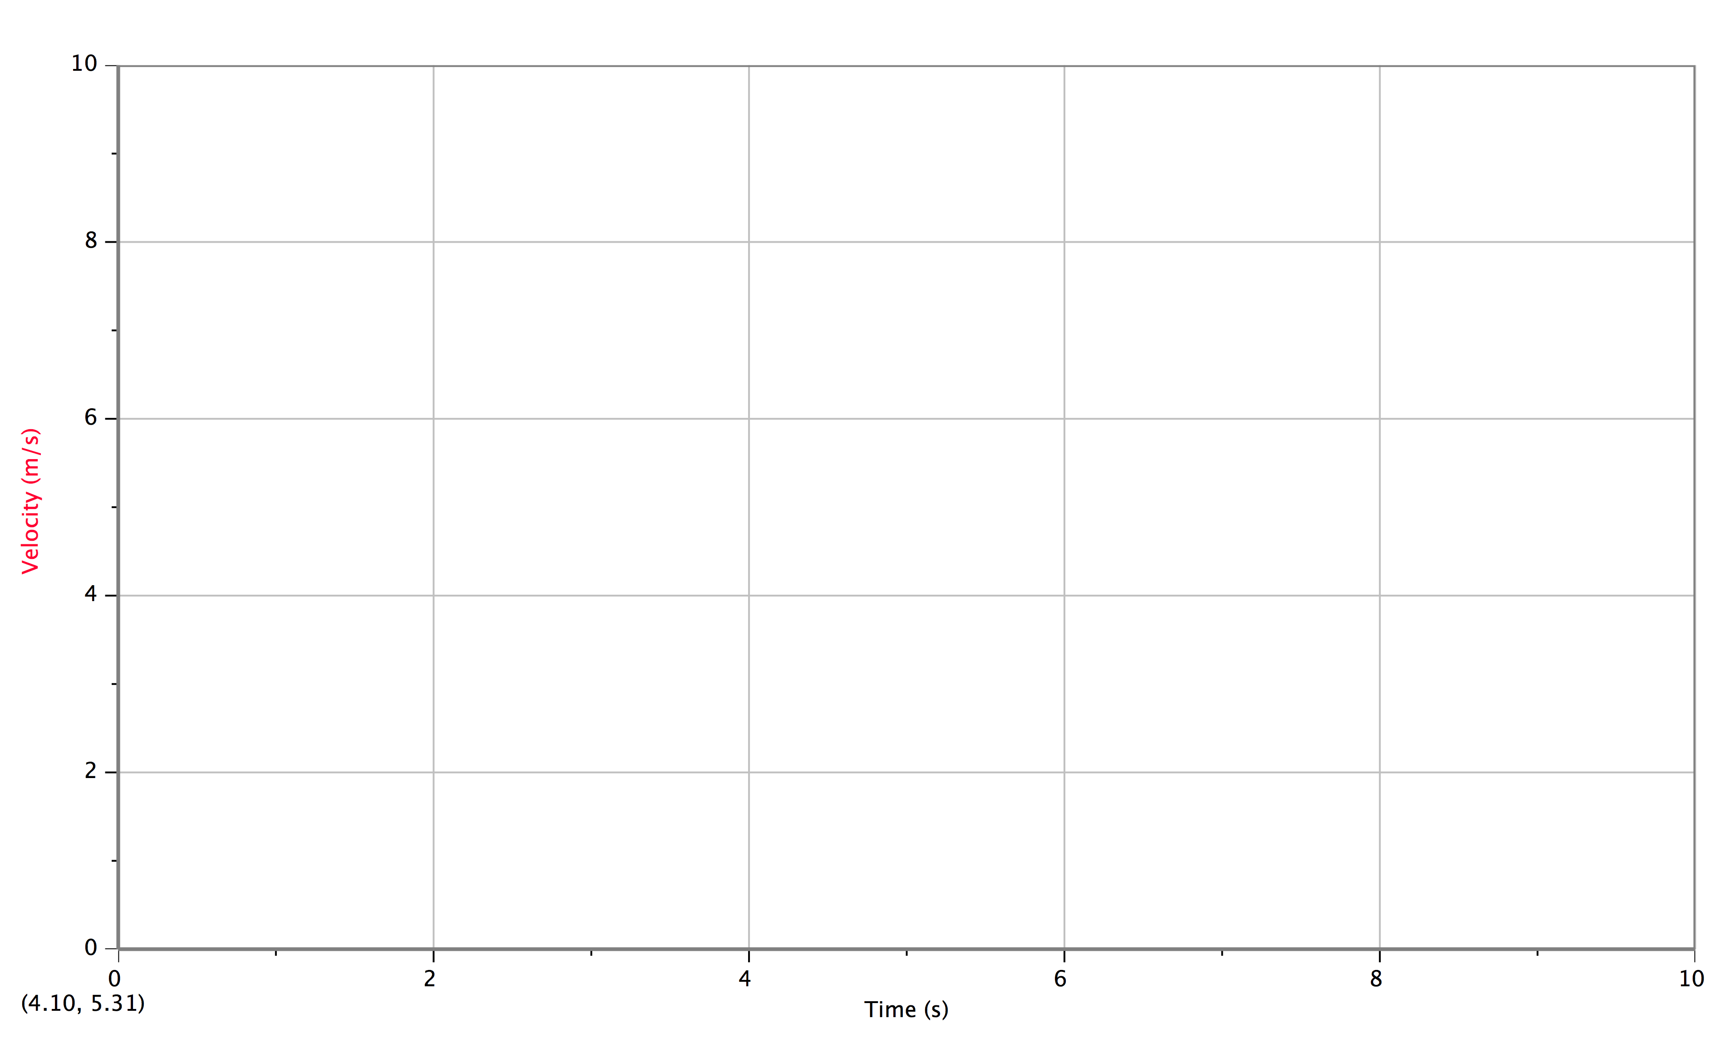

Part I – Preliminary Experiments
Part II – Position vs Time Graph Matching
Part III – Velocity vs Time Graph Matching

